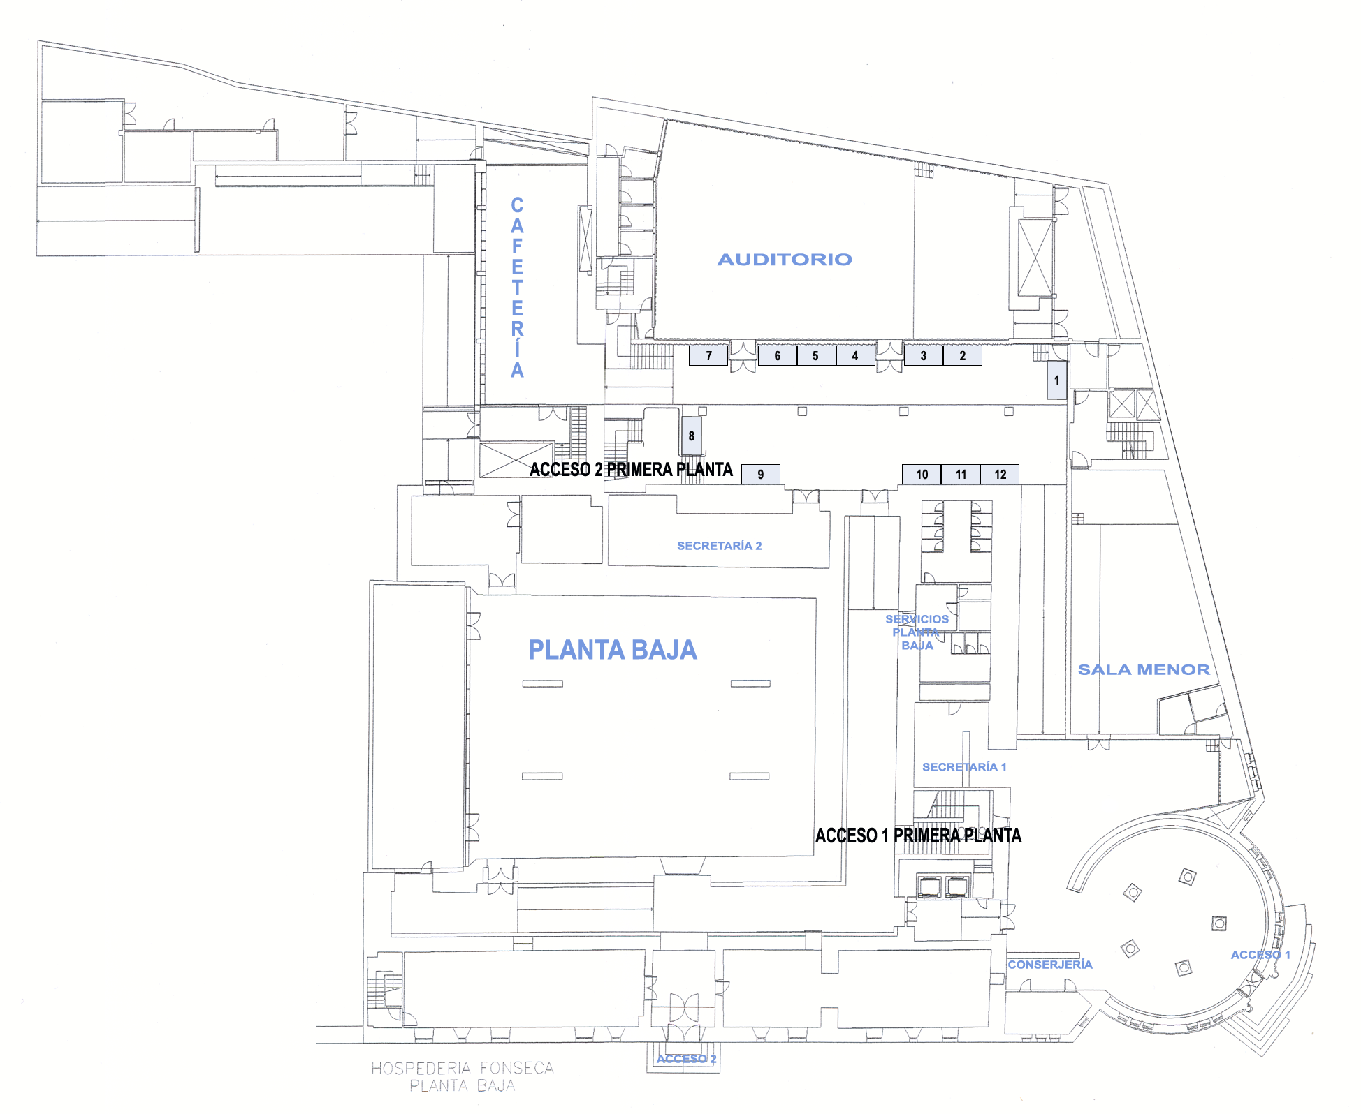

**INDIQUE EN EL FORMULARIO EL Nº DONDE DESEE SITUAR SU STAND.**

**INDICATE IN THE BOOKING FORM THE NUMBER WHERE YOU WOULD LIKE TO PLACE YOUR STAND**